H.T No
Regulations:
A15

Sreenidhi Institute of Science and Technology
(An Autonomous Institution)
Code No: 5A242 Date: 28-Mar-2023 (AN)

B.Tech I-Year II- Semester External Examination, March/April-2023 (Supplementary)
NETWORK ANALYSIS (ECE and ECM)

Time: 3 Hours Max.Marks:75 Note: a) No additional answer sheets will be provided.
b) All sub-parts of a question must be answered at one place only, otherwise it will not be valued.
c) Missing data can be assumed suitably.

Bloom's Cognitive Levels of Learning (BCLL)
Remember | L1 | Apply | L3 | Evaluate | L5
Understand | L2 | Analyze | L4 | Create | L6

Part - A Max.Marks:25

Answer all QUESTIONS.
 |  | BCLL | CO(s) | Marks
1 | State Kirchoff laws. | L1 | CO1 | [2M]
2 | Define (i) Tree (ii) Graph (iii) Chord. | L1 | CO2 | [2M]
3 | Derive expression for i(t) in series R-L circuit. | L3 | CO3 | [2M]
4 | State superposition theorem. | L1 | CO4 | [2M]
5 | Convert Z parameters interms of Y parameters. | L2 | CO5 | [2M]
6 | What are initial conditions? Why are they necessary? | L1 | CO6 | [3M]
7 | Explain the concept of duality. | L2 | CO1 | [3M]
8 | Define band width and quality factor. | L1 | CO4 | [3M]
9 | Define time constant for R-L circuit. | L1 | CO5 | [3M]
10 | State source transformation technique. | L2 | CO2 | [3M]

Part – B Max.Marks:50
ANSWER ANY FIVE QUESTIONS. EACH QUESTION CARRIES 10 MARKS.

 |  |  | BCLL | CO(s) | Marks
11. | a) | Find the equivalent resistance across the terminals a, b in the circuit shown below  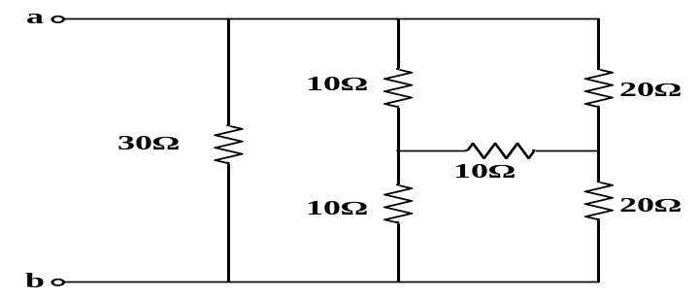 | L2 | CO1 | [5M]
 | b) | Classify different types of sources. | L4 | CO1 | [5M]
12. | a) | Draw the dual of the network shown below  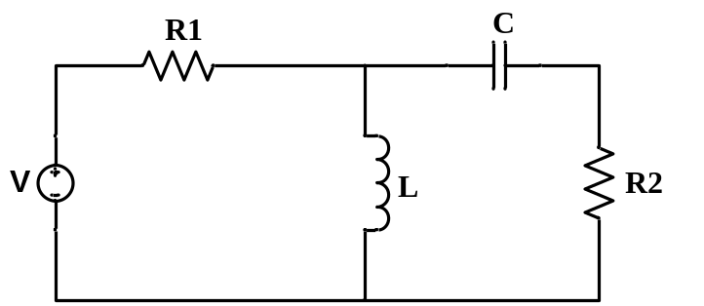 | L2 | CO2 | [5M]
 | b) | What are the properties of incidence matrix | L1 | CO2 | [5M]
13. | a) | An alternating voltage of (80+j60)V is applied to a circuit and the current flowing is (4-j2)A. Find (i) impedance (ii) phase angle  (iii) power factor (iv) power consumed. | L2 | CO3 | [5M]
 | b) | Derive expression for resonant frequency in a series R-L-C circuit. | L4 | CO3 | [5M]
14. |  | Find current through 3Ω resistor using thevenin’s theorem.  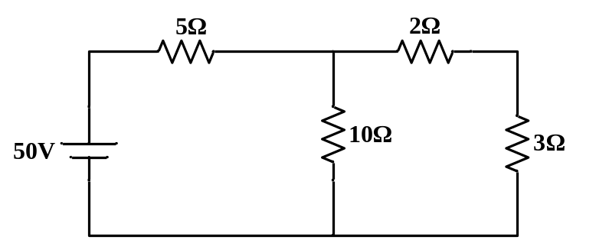 | L2 | CO4 | [10M]
15. | a) | Find Z-parameters of the network shown below.  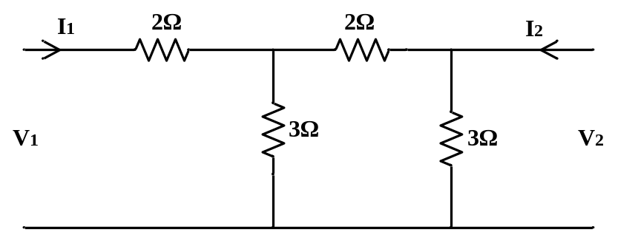 | L2 | CO5 | [5M]
 | b) | Derive condition for reciprocity and symmetry of ABCD parameters | L4 | CO5 | [5M]
16. |  | Derive expression for i(t) and voltage across inductor V_{L}(t) for series R-L circuit at t = 0. | L2 | CO6 | [10M]
17. | a) | A series R-L-C circuit has the following parameters R=17Ω, L=38µH, C=44µF. Calculate resonant frequency and under resonant condition, calculate current and power if the applied voltage is 70V | L2 | CO1 | [5M]
 | b) | Derive expression for energy stored in capacitor. | L4 | CO2 | [5M]
18. | a) | State and explain maximum power transfer theorem | L2 | CO4 | [5M]
 | b) | Draw and explain equivalent network of Y-parameters. | L2 | CO5 | [5M]

-- 00 -- 00 –

